January 9 | Critiquing Films! | Working as a Team!
January 16 | Working as a Team! | - New Year's Quiz  - Word "Puzzle" Game
January 23 | 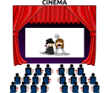 To 1st Run Movie!
January 30 | Scenes from a Movie! | Choosing; Acting and Filming with your Group!
February 6 | Olympics start tomorrow:  How to get the most out of watching! | Scenes from a Movie! SPORTS!
February 13 | Out in the Community  Interviewing RE: Valentine's Day | Other activities TBD
February 20  TIME CHANGE FOR CLASS!!  3:30-8:30pm  Info. on Transportation Coming Soon! | My Hero Brother  This meaningful documentary follows a group of young people with Down syndrome and their siblings, who embark on a demanding trek through the Himalayas. During their difficult journeys, their relationships are tested and strengthened. | 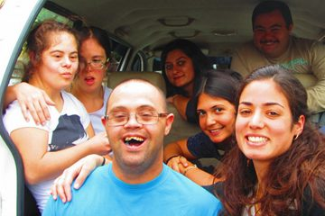 7pm at Kenwood Theatre  Film: FREE Dinner: Bring $10-$15
February 27 | Getting ready for our Oscar's party on Friday! | Our Film class will be the Hosts of the Party for WALL on Friday so..we're also the Planners!  COME WITH GREAT IDEAS!
March 6th | RESULTS!!! Watching Interviews  from Friday's WALL event! | Scenes from a Movie! Oscar Winners!
March 13th | Out in the Community  Interviewing RE: St. Patrick's Day | Other activities TBD
March 20th | To 1st Run Movie!
March 27th | Scenes from a Movie! | Choosing; Acting and Filming with your Group!
April 3rd | Scenes from a Movie! | Choosing; Acting and Filming with your Group!
April 10th | St. Vincent de Paul | Activity TBD
April 17th | To 1st Run Movie!
April 24th | Last Day of Class | Activity TBD

Goals for this Class that align with the philosophy of the Employment First Initiative: Working as a Team; Sharing Ideas; Accepting Constructive Criticism; Accessing the Community; Being Safe; Personal Wellness and Healthy Relationships

