January 11 | Finish up Goals.  In large Group discuss countries and what things we might want to be looking up for each country | 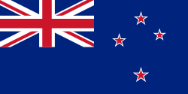 New Zealand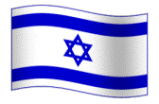Israel  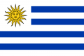 Greece
January 18 | 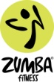 Bed Making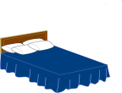Laundry | Getting organized!!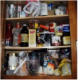
January 25 | 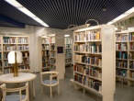 To Library New Zealand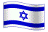Israel Greece  To Library to do research on our Countries! | Movie from  The Piano
February 1 | OR OR 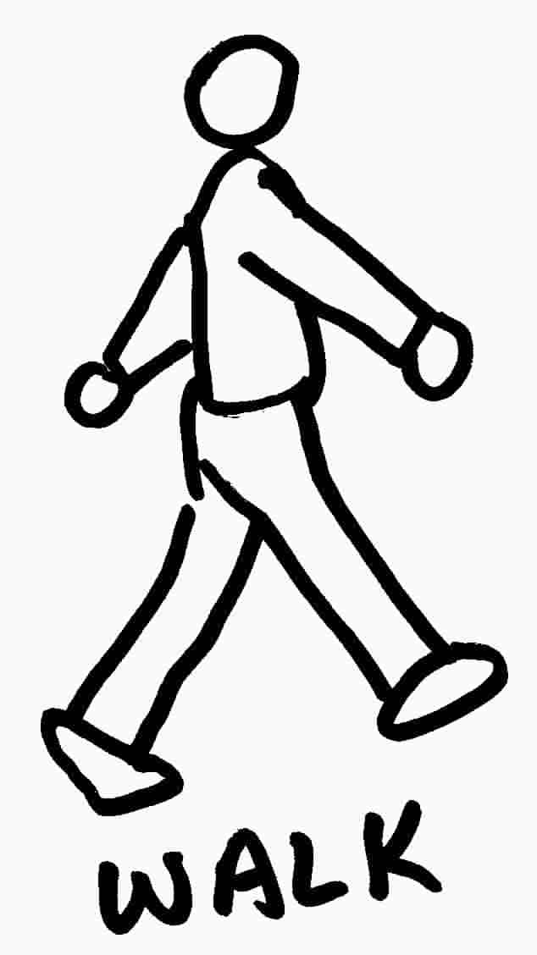 + 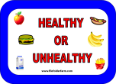Eating Habits | Dinner Challenge! More Info soon!
February 8 | To Library New ZealandIsrael Greece  To Library to do research on our Countries! | Movie from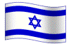  Every Time We Say Good-Bye
February 15 | OR OR + Eating Habits
February 22 | To Library New ZealandIsrael Greece  To Library to do research on our Countries! | Movie from  Mama Mia
March 1 | OR OR + Bed MakingLaundry | Getting organized!!
March 8 | Eating Habits and Foods from our countries! New ZealandIsrael Greece | Trip to  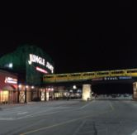 Jungle Jim's 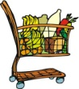
March 15 | OR OR + Eating Habits | CookingFoods from our countries! New ZealandIsrael Greece
March 22 | New ZealandIsrael Greece: DANCING | MusicArts & Crafts
March 29 | OR OR +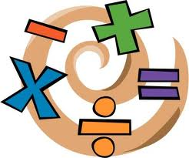  INTRO to BUDGETING! | Assessment of Money Skills.
April 5 | New ZealandIsrael Greece: DANCING | MusicArts & Crafts
April 12 | OR OR + Bed MakingLaundry | Getting organized!!
April 19 | SPA DAY! Everyone's Favorite Day! | Last minute Details  New ZealandIsrael Greece
April 26 | New ZealandIsrael Greece | Presentations and Foods! ( Look for an Invite!)
Goals for this Class that align with the philosophy of the Employment First Initiative: Working as a Team; Sharing Ideas; Accepting Constructive Criticism; Accessing the Community; Being Safe; Personal Wellness and Healthy Relationships
New Zealand:  EMcD; Ginelle; Lindsay;  Kelly L., Ann L.; Brooke | Israel:  Lisa C.; AMG; Patrice; Allyson; Jamie; Lisa R.; Lisa L.; Andrea | Greece:  Lauren B.; Lauren R. Rebecca F.; Julia; Kristina; Katie

